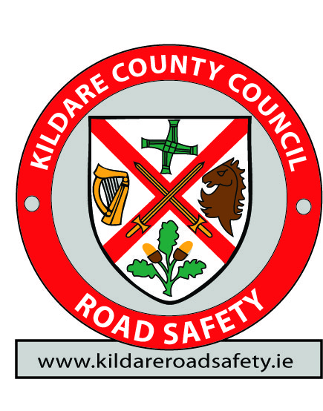
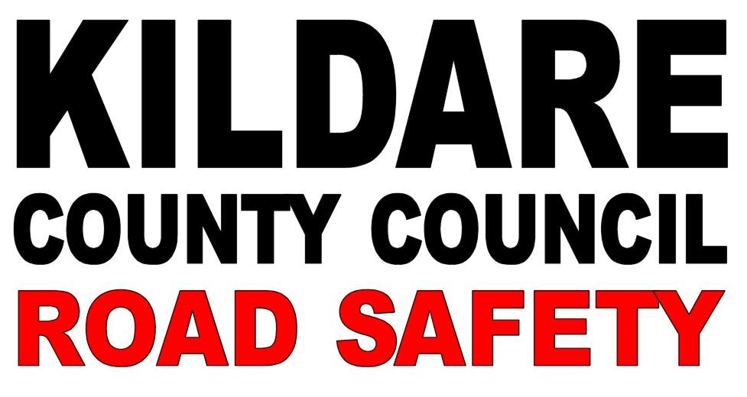

Form KRS_Expo_Sch1

‘Kildare Road Safety’
‘Safety Awareness Info Expo’
Punchestown Event Centre, Co. Kildare.
11th December 2014
Secondary Schools Attendance Form

School Name
Address
Town |  |  |  |  | County
Principals Name
Coordinator’s Name
Coordinator’s Mobile
E-mail Address
This school WILL attend the Road Safety Expo on Thursday December 11th 2014. |  | YES | NO | Reason for Not Attending…
Across, please indicate:  Group Type,  Student Numbers and  Numbers Male or Female | Year Type |  | Class | Students |  | Male |  | Female
 | Transition Year
 | Leaving Cert Applied
 | 5th Year Class
 | 6th Year Class
Please indicate if you require any disabled access.

SCHOOLS SOCIAL MEDIA DETAILS:
Website
Facebook Address
Twitter handle and Name

IMPORTANT NOTICE
COMPLETED FORMS SHOULD BE RETURNED via email to: roadsafety@kildarecoco.ie or post to:
Declan Keogh, Road Safety Officer, Kildare County Council, Áras Chill Dara, Naas, Co. Kildare.

